

**Faculty of engineering - Shoubra Benha University**

**Research Article / Research Project / Literature Review**

in fulfillment of the requirements of

|  |  |
| --- | --- |
| **Department** | **Engineering Mathematics and Physics** |
| **Division** | **-----------** |
| **Academic Year** | **2019-2020 Preparatory** |
| **Course name** | **Computer** |
| **Course code** | **ECE001** |

**Topic: -**

**Mobile Computing**

|  |  |  |  |  |
| --- | --- | --- | --- | --- |
|  | Name | Edu mail | B.N | Date |
| 1 | **Ahmed Hany Mohamed Shawky Hafez** | **ahmed195151@feng.bu.edu.eg** | **147** | **27/5/2020** |

**GitHub link :** [**https://github.com/ahmed-hany-shawky/ece001**](https://github.com/ahmed-hany-shawky/ece001)

**GitHub page :** [**https://ahmed-hany-shawky.github.io/ece001/index.html**](https://ahmed-hany-shawky.github.io/ece001/index.html)

**Examiners committee**

|  |  |
| --- | --- |
| **Signature** | **Examiners committee** |
|  | Dr.Ahmed Bayoumi |
|  | Dr.Shady Elmashad |
|  | Dr. Abdelhamid Attaby |

**Application brief :**

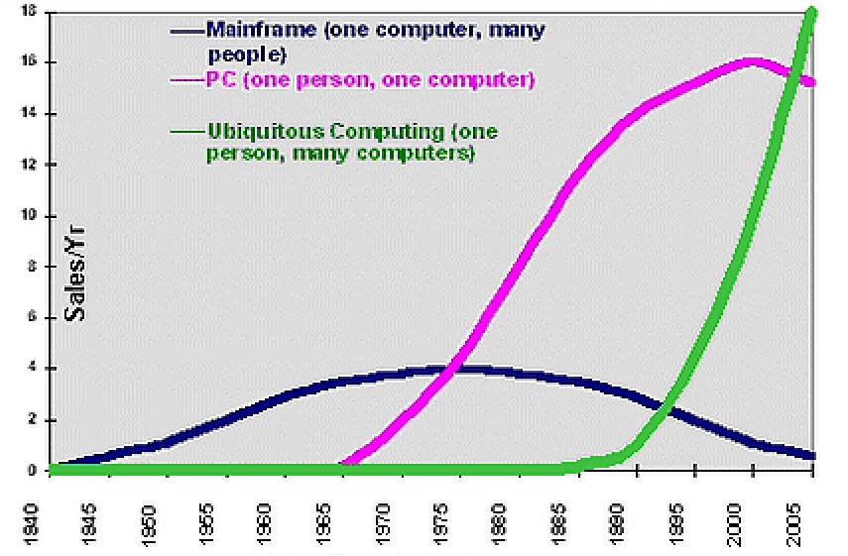**Mobile Computing:** With the rapid technological advances in **artificial intelligence**, integrated circuits and increased computer processor speeds, the future of mobile computing seems increasingly exciting.With an increasing focus on small and small laptops, it may also be possible to have all the practical aspects of a laptop in the size of a handheld organizer or even smaller. The use of artificial intelligence may allow portable units to end up in a personal secretarial, which can receive emails and summons, understand what they are around, and change the personal schedule of individuals according to the message. The individual can then check it out to plan his day.The business lifestyle will change, as most people work from home, rather than move around. This could be beneficial to the environment as less transportation will be used. This mobility aspect may be further transferred because even in social areas, people will interact via mobile stations, eliminating the need for adventure outside the home.This frightening concept of a world full of zombies sitting, locked on their mobile stations, and reaching every area of ​​their lives via a computer screen becomes more realistic than ever with the improvement of technology, especially in the field of mobile data communications, and as shown on the right side, the trends are to the extent Great towards ubiquitous or mobile computing.As more people use computers, mobile phones and tablets, mobile computing will become more popular.Today, computing has grown rapidly from being confined to one place. With portable computing, people can work comfortably wherever they want as long as communication and security concerns are properly taken into account. In view of this, the presence of high-speed connections also enhanced the use of mobile computing.As it is a constantly growing and emerging technology, mobile computing will continue to be an essential service in computing and ICT.By 2020, the use of mobile computing in health care will extend the life expectancy of 20 to 25 years. The implanted wireless devices will constantly monitor our health, enabling the medical profession to treat most diseases in her infancy. Mobile computing will also be used to monitor our diet and its effects on our health, control unhealthy habits such as smoking and alcohol consumption, and enable us to maximize the effects of exercise. Diseases like diabetes will be controlled roughly with wireless monitoring and corrective action devices, which will automatically adjust insulin levels without the patient's knowledge. Phil Asmondson, Deputy General Manager, Technology, Media & Communications Group, Deloitte & Touche LLP, Stamford, Conn. , Office Today, computing has grown rapidly from being confined to one place. With portable computing, people can work comfortably wherever they want as long as communication and security concerns are properly taken into account. In view of this, the presence of high-speed connections also enhanced the use of mobile computing.As it is a constantly growing and emerging technology, mobile computing will continue to be an essential service in computing and ICT. Today, computing has grown rapidly from being confined to one place. With portable computing, people can work comfortably wherever they want as long as communication and security concerns are properly taken into account. In view of this, the presence of high-speed connections also enhanced the use of mobile computing. As a constantly growing and emerging technology, mobile computing will continue to be an essential service in computing and information and communication technol.

**Fig 1**

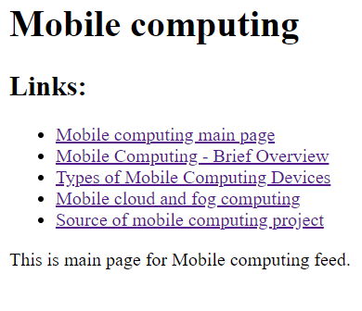**Screenshots :**

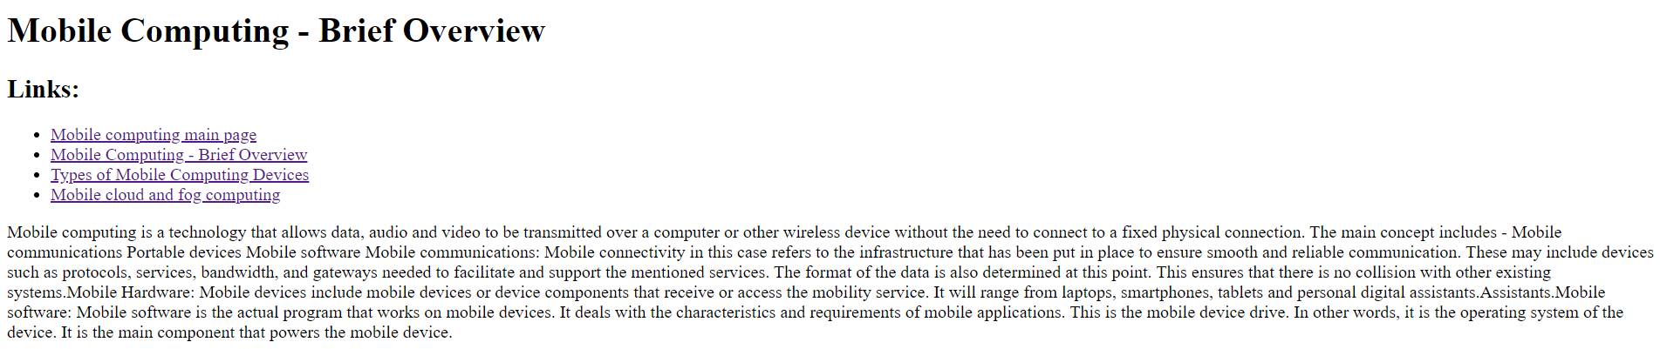

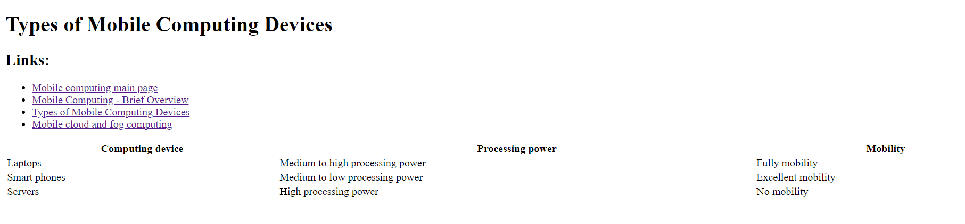

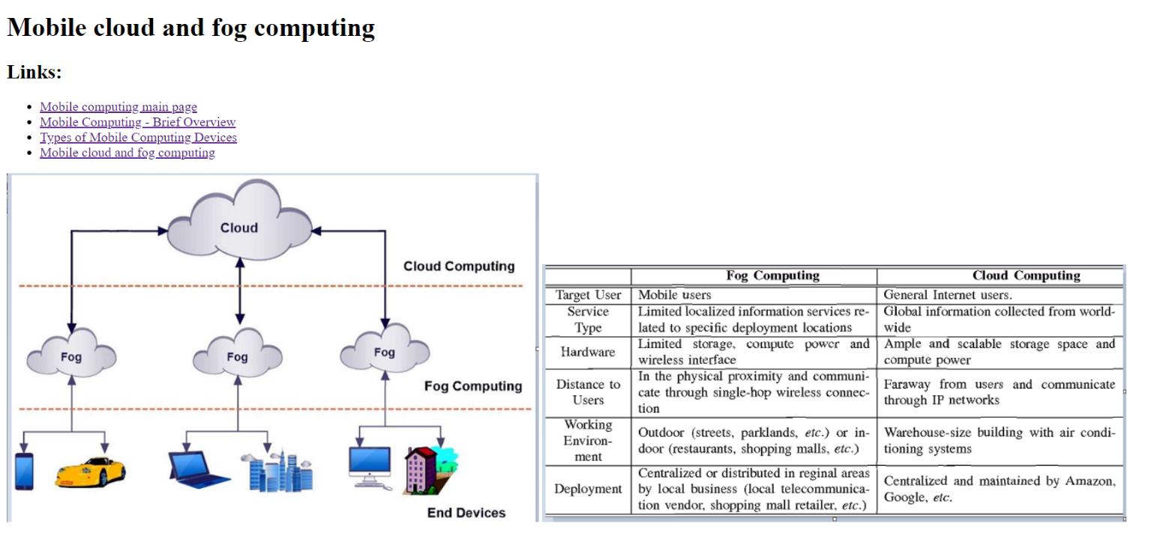

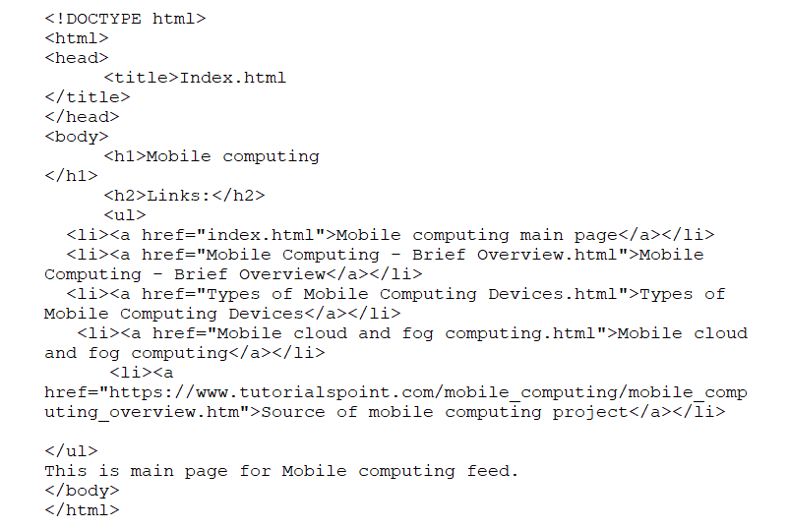**Source code screenshots:**

